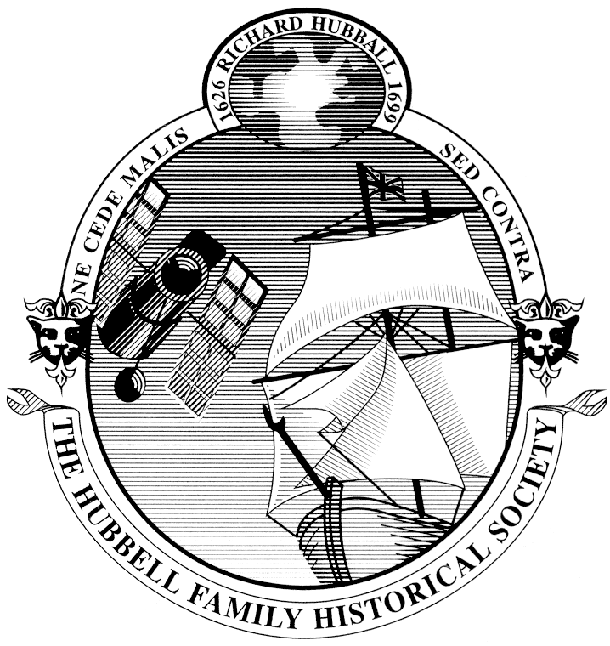
The Hubbell Family Historical Society
2017 Reunion – Long Beach
Registration Form
Registration Fee per person $ 45 x ___ = $____________
Banquet tickets $ 62 x ___ = $____________
Children Under 6 FREE
Children ages 7 – 14 half of the prices listed
All day tour to the Mount Wilson Observatory and the Jet Propulsion Laboratory’s where Edwin Hubble worked $ 55 x ___ = $____________
TOTAL __________________
Tour of the Queen Mary – free with Hotel registration or
$ 15 payable onsite to the Tour desk if you are not staying on the Queen Mary.

.

Name: __________________________________
Address: ________________________________
________________________________________
City: ____________________________________
State/Prov: ______________________________
Postal / ZIP Code: _________________________
Email: __________________________________
Number of People registering _______________

Name for each person as you would like it to read on their Badge

_________________________________________ ____________________________________________

_________________________________________ ____________________________________________

Please add additional sheets for additional participants

Register your stay aboard the Queen Mary Directly with the Hotel at www.queenmary.com The group code is HUB0617 - or call them at (877) 342-0738
Mention the Hubbell Family Historical Society to get the Member rate.

PLEASE INCLUDE:
Check Number: _________________ Check Date: ______________ Check Total ______________
If known: Member Record Number
1995 Edition: ________________
1980 Edition: ________________
Send your order and Check Payable to:
Richard A Hubbell, 2017 Reunion Chair

340 Harding Street

Long Beach, CA 90805

e-mail: <rahubbell@hotmail.com>

The Hubbell Family Historical Society
2017 Reunion – June 16 – 19 Long Beach
The Hubbell Family Historical Society gathers every two years to meet cousins and do the family business. It is mostly fun, with some presentations, and a small amount of governance thrown in.
This year we will meet aboard the Queen Mary docked in its own special berth in Long Beach California. This historic ship is fascinating and tours are included in your stay. Register at http://www.queenmary.com and be sure to note you are part of the Hubbell reunion so you can get the room block rate. The group code is HUB0617 - or call them at (877) 342-0738
Draft Reunion Schedule.
- June 16 - Friday
  - AM - Board meeting
  - PM - First Family meeting
  - Friday Evening - Family Social Activities in the Family Room
- June 17 - Saturday
  - Explore Queen Mary and Long Beach
  - Family Room activities all day – puzzles, games, laughter
  - Presentations – times to be announced
    - Hubbell’s of the Severn Valley
    - Hubbells in England Presentation
    - Trace your own family – Learn how to use the book
    - Edwin Hubble
- June 18 - Sunday AM
  - Church Services by Stephen Hubbell
  - Or a Free morning
PM - Second Family Meeting
  - Evening – Banquet in one of the ships Grand Art Deco Ballrooms –
  - Awards and then entertainment
  - Consider dressing in a 1930’s style
- June 19 - Monday
  - All day tour to the Jet Propulsion Laboratory, which operates the Hubble Space Telescope, and to the Mount Wilson Observatory where Edwin Hubble worked.
  - Evening - Second Board Meeting - Monday night
Family Room and Shop open

Long Beach is an easy destination via Amtrak, or Los Angles and John Wayne (Orange county) airports. There are frequent shuttles. Parking is $20 per day. It is a short ride to Disneyland, a short sail to Catalina Island, Whale watching cruises leave right from the Queen Mary dock. Long Beach itself is rich in activities, a lovely beach, world class aquarium and you can reach it on the Long Beach Passport - Free bus service from the Queen Mary to the Pike and Shoreline Village tourism district of Long Beach.
We encourage gatherings of family sub group, enjoying Long beach Aquarium, Beach, Water Front, Port tours and hanging out in the family room playing board games and doing jig saw puzzles. Come early and spend some time on Tuesday or stay late and see more sights on and Thursday.
Come join us!

