424 Ponus Ridge
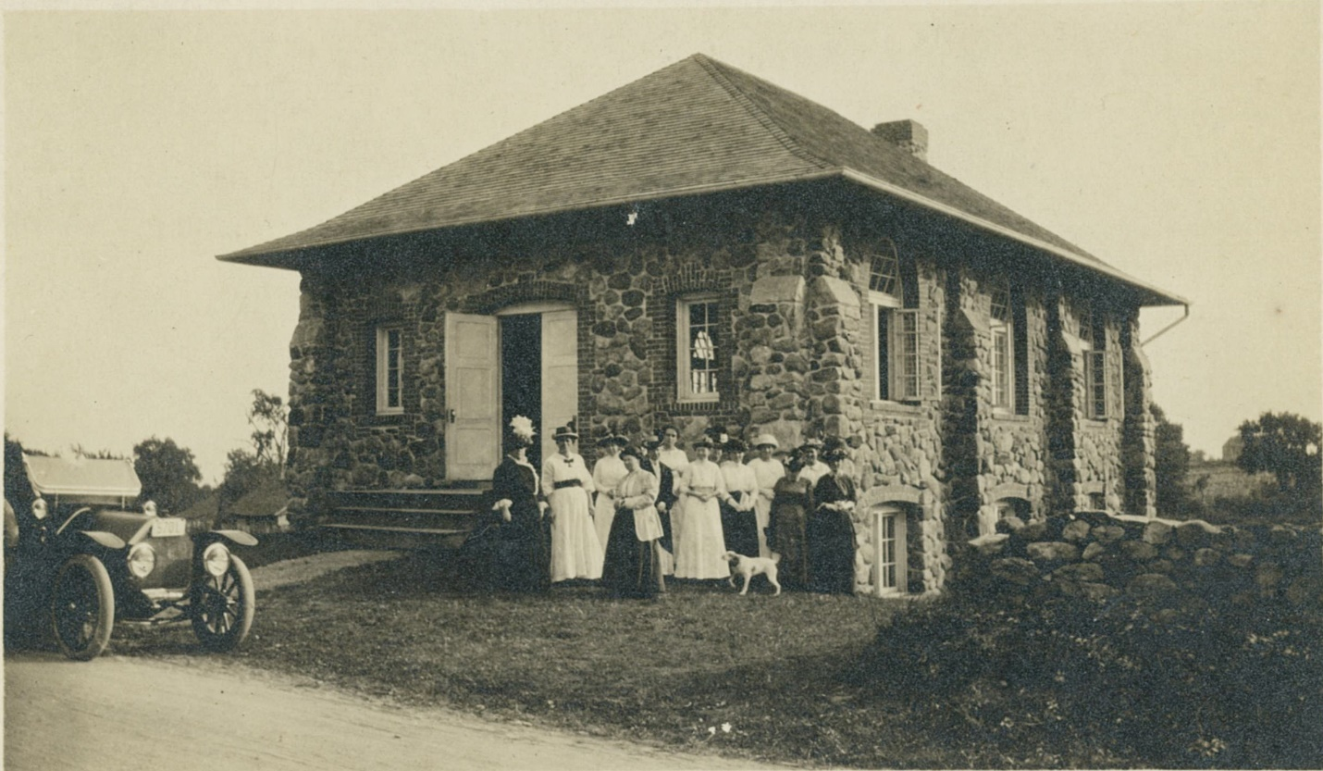
Ponus Ridge Chapel ca. 1917. Courtesy of the New Canaan Museum & Historical Society

New Canaan, CT
The history of the Ponus Ridge Chapel begins in 1902 when a group from the Ponus Ridge area began to hold church services and a Sunday school in a butcher shop on Davenport Ridge.
In 1907, the group formally organized as the Ponus Street Union Chapel, a non-denominational Christian group. In their first meeting, a building committee was created to find land and build a dedicated meeting space. Both Levi S. Weed and Charles E. Hubbell sold a part of their land to the committee for $1. In total the parcel was 25′ by 100′. The chapel itself was designed by Charles E. Hubbell and Charles A. Luckhurst both Ponus Ridge residents and architects. The stone came from local farms, predominantly from the Thurton farm across the street.
Two hundred people attended the chapel dedication on September 10, 1911. It quickly became the center of the community for the area. Six weddings and a funeral were held in the chapel in its first forty years. Many local fairs were hosted from the chapel. One such fair was centered around the dedication of a bell for the chapel. Edward Lawerence married Fanny Davenport and so to replace the “belle” that he was taking from the ridge, he gave the chapel a bell in return. During WWI, the chapel was used by the Ladies’ Aid Society for what is described as “Red Cross work.” This group of women is most likely the group depicted in the picture above.
By the 1930s, activities in the chapel had slowed down. The advent of the automobile made it easier to travel to larger churches. Eventually the chapel offered only a single service each year, which in turn was discontinued. Despite this, it remained a center of the community holding holiday parties, dances, and tag sales, as well as an art class every Saturday morning.
Unfortunately in the late 1940s, a fire from an adjacent field destroyed the roof and much of the interior. Luckily insurance on the building covered the damages and additional funds were raised to install a heating system, stairs, and a new basement floor. Later a kitchen and modern plumbing were added. In 1951, the chapel organization was restructured as the Ponus Ridge Chapel and Community Association. By the 1970s, however, the chapel was in disrepair and, in 2018, the property was transferred to a private owner, who restored it as a guest house.
“New Canaan Now & Then” is presented in partnership with the New Canaan Museum & Historical Society.

