The Gutiérrez-Hubbell Estate: A Census Study of Intergenerational  
Intersections of a Family and their Servants

1

Samuel E. Sisneros

© 2013, revised 2024

In 1884, Tomás Gutiérrez, the brother of Juliana Gutiérrez de Hubbell, sent notice to their older sister, Ana María Gutiérrez that the family estate corral wall at Pajarito, New Mexico had fallen and urged Ana María to have her “*peones*” rebuild it.1 Tomás’ appeal for peon (servant) labor demonstrates that after nearly forty years under the U.S. government, the Gutiérrez, Hubbell and other Pajarito elite Rio Abajo families continued with the Spanish colonial practice of servitude and peonage which expanded in New Mexico during the Mexican and United States political and cultural systems.

The village of Pajarito is located six miles south of Albuquerque central district on the west bank of the Rio Grande and is now incorporated into the South Valley section of Albuquerque. It was part of a Spanish land grant given to the Gutiérrez/Hubbell family’s matriarch, Josefa Baca prior to 1746.2 The land grant was sold to Clemente Gutiérrez and Apolonia Baca (daughter of Antonio Baca and granddaughter of Josefa Baca) in 1785 and portioned out to their children.3

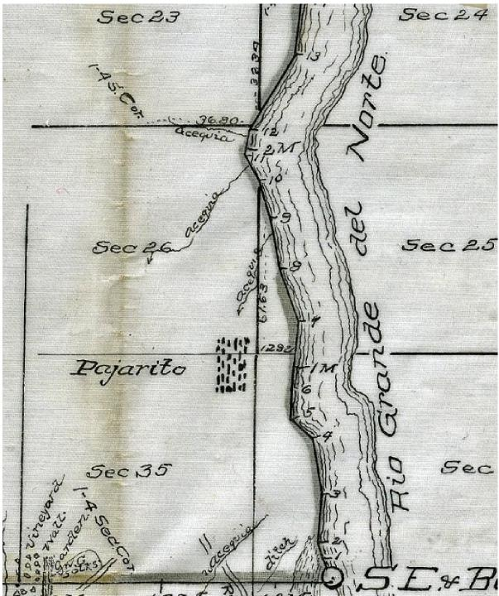

Map detail. Pajarito Grant Map, Thomas B. Catron Papers (MSS 29 BC), CSWR, University of New Mexico

Tomás, the petitioner for *peones* to rebuild the adobe wall, and his two sisters, Ana María Gutiérrez and Juliana Gutiérrez de Hubbell were the children of Juan Nepomuseno Gutiérrez and Barbara Chávez, head elite landowners of Pajarito. Juan Nepomuseno was the son of Lorenzo Gutiérrez and Candelaria García and grandson of Clemente Gutiérrez and Apolonia Baca. The family’s Gutiérrez/Baca forefathers and foremothers used the labor of Indian servants to work their estates which set the stage for the intergenerational practice of servitude allowing the family to maintain an economic and social stronghold in Pajarito from the 1700s into the 1900s.

2

Three known censuses were taken of Pajarito during Spanish rule for the years 1750, 1790 and 1802. The 1750 Pajarito census included nine households all of which were Baca family members.4 The enumerations included first and last names of the heads of household along with the first names of children and servants, but age or race are not noted. Each household had from one to ten house servants (most likely Indian). The head rancher family was that of Antonio Baca and Monica Chávez which included ten servants. Another Baca family had seven servants. The 1750 Pajarito population was 76 persons with 51 from the Spanish landowner class and 25 from the Indian house servant class.

In the 1790 Pajarito census (Puesto de San Ysidro de Pajarito) it is noticeable that, while the Spanish and Mestizo farmer class families grew steadily, the servant class grew exponentially. Even though this census only gave names of heads of households (parents in most cases) it did list the gender, age and race of each household family member and servants. First to be enumerated were the ranching Spanish class families with eight households - all but two households were from the Baca/Gutiérrez extended family.

1790 Census, Isleta Jurisdiction, SANM II, 1092B, New Mexico State Records Center and Archives

The head household in 1790 was that of Apolonia Baca (Doña Polonia), widow, (of Clemente Gutiérrez) with two unnamed family members and four unnamed Indian servants - one of which was noted as

Comanche, and one as Apache. Within each of the other Spanish rancher families (36 persons) there were two to four house Indian servants (18 persons). Noted tribal affiliations of Indian house servants were Coyote5, Comanche, Apache, Navajo and Ute. Following the grouping of rancher families with their house servants were twenty-four households of the laborer class who were listed as Indian and mixed bloods with the heads of households totaling: 6 Indian, 12 Coyotes, 17 Mestizos, 4 Spanish, and 1 Mulato. Fourteen of the male heads of these families (of all racial castes) were listed as servants, six as day-laborers (*jornaleros*), and one sheepherder. Two Spanish heads of households were included as servants. The fact that the children’s and servant’s names were left out of the 1790 census combined with the ages omitted in the 1750 census makes it difficult to follow the servant families generationally during this period. Adding to this research obstacle, the baptismal records for San Agustín de Isleta Church (parish for Pajarito and Los Padillas people) are missing for the years 1776-1829.

3

The 1802 Pajarito census was not a true population census but rather a listing of select families that contributed to a religious confraternity. No ages were given in this census. Three households only were listed, and all were part of the Gutiérrez family. Within the Lorenzo Gutiérrez household was his mother Apolonia (widow) and six other family members. This household included three servants: María Savina, Josefa and Rosalia. The other servant listed was Rosa Gutiérrez who lived in the Mariano de la Peña and María Soledad Gutiérrez household. María Soledad was the daughter of Clemente Gutiérrez and Apolonia Baca.

Because of inconsistent demographic data in these colonial censuses and the extended periods between the censuses, this kinship study will not attempt to make connections to and between early Native American servant families associated with the Baca/Gutiérrez family. Instead, it will only make intergenerational connections during the period from 1850 (two years after the U.S. military occupation and annexation of New Mexico from the Republic of Mexico) to 1940 since during this time censuses took place every decade. The following historical chronology, constructed from the U.S. censuses along with other primary sources, documents the family lineages descending from Juan Nepomuseno Gutiérrez and Barbara Chávez and trails the parallel descendancy of their Native American house servants, dependent farm laborers (peons), and day laborer neighbors. The U.S. censuses generally noted a household’s members and their relationship to each other along with their age, social status, occupation, assets, and race. By examining the families’ households as they were enumerated in the U.S. Censuses, social and kinship structures can be observed - demonstrating that the practice of Indian servitude and peonage was uninterrupted since the 1700s as was the intergenerational intersections of these families.

1850 U.S. Census

4

The 1850 census of Pajarito listed Juan N. (Nepomuceno) Gutierres, age 54, as a farmer and merchant with real estate valued at $1100.00, which was two to three times more than his Pajarito neighbors. His wife Barbara is listed next, followed by their children Francisco, 24; Roman, 21; Juliana, 15, and Tomás, 10 (discussed in introduction). Ana (also discussed in introduction) was apparently absent during this census. Also listed in the household after the Gutiérrez children, is J.L. (James Lawrence) Hubbell, age 24, (Anglo-American) and farmer merchant. Listed after J.L. Hubbell was Francisco Santiago, 7 months old, who was the first born of James Hubbell and his wife Juliana Gutiérrez. Apparently because of Juliana’s young age she was still listed under her parents instead of with her husband and their child. The household listing continues with the following additional persons: María Antonia Gutiérrez, 28; Juana Sara, 33; Martín, 3; Juan, 13; and Francisco, 13. The enumerator listed all residents in the Gutiérrez dwelling as White and omitted the occupation of the additional household members, which were indeed Indian or Mestizo house servants of the family estate as subsequent censuses and other documents reveal. This household positioning within this census enumeration is consistent with most regional censuses which include the house servants as additional persons at the end of the list of household occupants. It was also common practice in census taking to immediately list the adjoining houses of an estate’s farm laborers.

Following Juan Nepomuceno’s household were four dwellings with heads of households listed as servants who most likely would have labored in peonage for the Gutiérrez family. These families were:

- Rafaela Baca, 40, (widow of José Chávez?); servant adult son Julian (Chávez?), 23; José Angel, 21, laborer; Ramon, 17, laborer.

- Dolores (male) Muñíz, servant and wife Juana (Marques), 30; Pablo, 20; José, 16; Dolores (female) 12; Francisco, 7; José Incarnacion, 6 months.

- Juan Morada (Moraga), servant, 50; wife Juana Dominga (Montoya) 41, and José, 3.

- José Antonio Montoya, servant, 31 and wife Juana Chávez (daughter of José Chávez and Rafaela Baca), 28; José, 5; and Santos, 1.

These farm servant/laborer families were from the Mestizo class/caste and some appear to be previous residents of Los Padillas (neighboring village) as church records demonstrate. 6 They, along with the Indian house servants became some of the core Pajarito families and continued for generations to intermarry and maintain association with the Gutiérrez and Hubbell families either through servitude and peonage or as farm laborers, boarders, store patrons/debtors, tenants, godparents, friends, neighbors and relatives. As we shall see in subsequent censuses, they intermarried with the Rubí, Peña, Durán, Yturrieta, Ortíz, Castillo, Chávez, Anaya, Sánchez, Barboa, Metzgar and other families.

1860 U.S. Census

The 1860 census reveals that servitude increased in Pajarito since 1850 as did the financial wealth of the Gutiérrez and newly formed Hubbell dwellings. The enumerator of this census identified

the residents’ race, which would factor into the identity of these residents throughout the remainder of the next century.7 Juan Nepomuceno Gutiérrez (real estate valued at $11,700 and personal estate at $25,373) and wife Barbara were now listed with two adult family members: Francisco Gutiérrez and Ana María Gutiérrez along with six house servants, three of which were listed as Indian and had the Gutiérrez surname. They were María Antonia Gutiérrez, 45 (in Gutiérrez home in the 1850 census); Carmel Gutiérrez, 35; Juan Gutiérrez, 19 (Carmel’s son?). The other house servants, María [Belin?], 45; Cornelia [Belin?], 10; and Juan Peña, 12, were all listed as white. Juan Gutiérrez, the Indian house servant, married house servant Cornelia five years after this census.8

5

In this census the family of James Hubbell and Juliana is listed in a separate dwelling following the Juan Nepomuceno Gutiérrez home. James Hubbell’s (real estate valued at $3000 and personal estate at $11,000) household listed their children: Santiago, Lorenzo, Luisa, and Charles and four house servants: María Hubbell, 21, Indian (born c.1839); Francisco Ilustre Muñíz, 21 (race not noted); Juana Vialpando, 14 (race not noted); Juan Gutiérrez, 13 (race not noted). The Francisco Muñíz in this household was the son of Dolores Muñíz and Juana Marquez. In 1865 Francisco married Juana Vialpando from the same household. Perhaps this Francisco Muñíz was the same thirteen-year-old “Francisco, servant” in Nepomuceno’s home in the 1850 census. If so, he was apparently given or transferred to the Hubbell household. The Moraga family noted in the 1850 census was now living as laborers in the neighboring house. Apart from the Gutiérrez /Hubbell family’s 10 house servants, there were an additional 33 house servants dispersed within various Pajarito families in this 1860 enumeration – eight of which were listed as Indian. Most of these servants were living in Chavez or Sarracino households.

Soon after this 1860 census, James Hubbell, as a military officer, raised a New Mexican volunteer company to counter the confederates during the U.S. Civil War and participated in various regiments. One of his regiments took part in the Battle of Valverde. Shortly after this battle, while doing a military tour in San Antonio (most likely town in New Mexico near Socorro) on April 7, 1862, James “Santiago” Hubbell was arrested for harboring in his wagon what Hubbell’s commanders called a “prostitute.” Hubbell claims she was his laundress whom he brought from Albuquerque. He had to leave her in San Antonio but was trying to get her back to her husband who was also Hubbell’s saddler.9 Although this episode appears scandalous and further scrutiny can be done, it certainly demonstrates that during the U.S. territorial period servants (laundress in this case) continued to be expendable and reveals that they served in a mobile capacity.

1870 U.S. Census

The 1870 census indicates that within the Gutiérrez and Hubbell dwellings, servants continued to live in-house and had children born into servitude. It listed Juan Nepomuseno Gutiérrez, 75 years old,

farmer with estate value of $10,000 and personal value of $5000 (largest amount in the village). His wife Barbara was 63, and their single adult children Roman, 40, and Ana, 45 were listed in the household. Carmen, 45, was still listed as an Indian domestic servant. Also listed was Josefa, a nine­year-old Indian. This Josefa is most likely the María Josefa, “*un indita de nacion navajo*” baptized August 19, 1864. The baptismal entry noted that this Navajo child was “de Ana Gutiérrez” meaning that she belonged to Ana.10 The 1870 census also registered the houses preceding Juan Nepomuceno’s dwelling as those of “laborer” families Francisco Muñíz, Alvino Rubí, and José María Sánchez.

6

The separate household of James Hubbell, 46, farmer had estate and personal value the same as his father-in-law. He and his wife Juliana (Gutiérrez), 37; and their children Santiago, Lorenzo, Louisa, Carlos, Felipe, Francisco, Tomás, and Barbara were all listed as White. Living as a separate family in James Hubbell’s dwelling was María Hubbell who was still listed as an Indian domestic servant, now age 32. With her was Juana, 2 years old, White (later noted as María Hubbell’s daughter), and Dolores Areanes, 12, White. Dolores would go on to marry José Moraga from the 1850 and 1860 Moraga servant family.11 Besides the four Indian domestic servants in the Gutiérrez /Hubbell households, this Pajarito census also listed five additional domestic servants living in Chávez households – four of whom were noted as Indian.

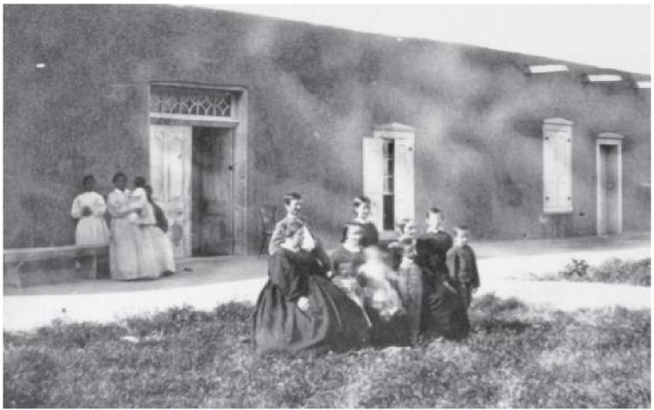

Image from Wilson, Chris, “Gutiérrez-Hubbell House: Dates & Sequence of Construction,” draft

report, January 28, 2013, in MSS 470, Brugge Papers, Box 12, Folder 44, CSWR. An original photo is at the NMSRCA.

Within the 1870 timeframe or later, a photo, estimated by some to be taken in 1867 and attributed to the photographer Alexander Garner, was taken without a doubt in front of what is today known as the Gutiérrez-Hubbell house in Pajarito (see image above). At the forefront of the photo are apparently Hubbell family members. In the background and standing in the shadow of the building are

three females of various ages and one baby in arms. Some have claimed they are servants of the Hubbell’s and even attributed names to them by pulling servant names listed in the Hubbell house in the censuses. But because the photo has not been positively dated, nor are the persons positively identified on the back of the photo or elsewhere, attributing names or social status to them would be mostly speculation. Perhaps the family in the forefront can be identified by comparing their likeness with those in other contemporaneous photos of the Hubbell family, but it is unlikely those in the background can be verifiably identified. If the family in the background were indeed servants, it is also possible that they could have been the servants of visiting neighbors or also visiting Hubbell kin from the eastern U.S. if they even had servants or would travel with them. This later scenario would mean they would have most likely brought Black servants with them. Regardless if work is still needed in identifying persons in the photo, this image provides a rare visual glimpse of the late 1800s to early 1900s Hubbell house - including a better regional understanding of period house architecture, dress and the social and cultural landscapes.

7

1880 U.S. Census

By 1880 more than 20 out of 84 Pajarito dwellings had persons listed as servants, domestic servants, boarders, servant laborers, and general farm laborers both Indian and “White.” With the death of Nepomuceno (1875) and wife Barbara Chávez de Gutiérrez (1876), Ana Gutiérrez became head of the estate. In this census Ana is listed as “Anita” (term of endearment for “Ana”), White, 66 years old. Listed with her was Carmel, the former servant of Juan Nepomuceno, who was now noted as a 60-year­old “domestic” Indian servant. Also, in the dwelling was Josefa, the former Indian servant listed in Nepomuceno’s 1870 household. She is now listed as an 18-year-old “white” domestic servant.

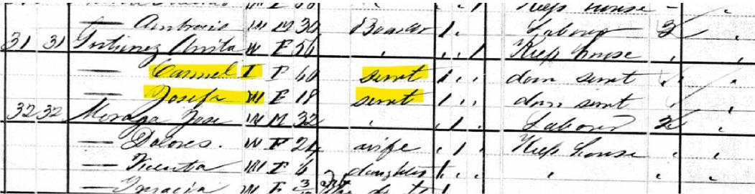

Detail of 1880 U.S. Census of Pajarito

Ana (Anita) took over her family’s estate and acquired the service of her parent’s house servants and the service of neighboring farm laborers referred to as her peons in the introduction of the essay. Elders Ana (Gutiérrez family member) and Carmel (Indian servant to the family) were the same age and regardless of their separate social position or racial difference, they would have known each other intimately as family since they grew up together in the same home. Interestingly, for unknown reasons,

perhaps either because of this relationship or Ana’s position as the new master and head of the household, it came to be that Carmel, at a late age, was baptized (or possibly re-baptized) in 1882 at San Agustin Church in Isleta.12 The baptismal registry notes her full name as Maria del Carmel Gutiérrez, a sixty-year-old adult adopted by Ana Maria Gutiérrez. The godparents were Ana Maria Gutiérrez and Tomás Jobel (Hubbell).

8

James Hubbell and Juliana’s dwelling listed their three children (Felipe, Tomas and Barbara) along with four boarders. Two of the boarders were James Hubbell’s parents (John L. and Sophia R.) apparently visiting from Litchfield, Conn. Also listed (as boarders instead of servants) were Maria Hubbell, now 44 years old (born c. 1836) and Juana, now 14 years old (born c. 1866). Maria’s race was originally marked with “IN” for Indian but was superimposed with a “W” for white. Juana was listed as white. The Francisco Ilustre Muñiz family, former house servants of James Hubbell follow the Hubbell household as a separate dwelling. José Moraga and Dolores Areanes, laborers, also continued to be listed in the immediate household.

1885 U.S. Census

Just five years later, another census was taken which reveals that the social roles, and racial/cultural identities of the Pajarito residents began to change. There was a sharp decline in people listed as servants and Indians with six out of forty-four dwellings listing servants. In the household of Juliana Gutiérrez de Hubbell she was enumerated as a fifty-one-year-old widow and head of household (James Hubbell died the same year on Feb. 5). With her were her youngest children Felipe and Barbara. The household had no house servants. Maria Hubbell and Juana Hubbell, the previous Hubbell house servants were now living in their own dwelling - liberated from the servant occupation with no Indian racial label. Maria Hubbell instead was noted as head of household, White, and a widow. Juana Hubbell is now listed as her 19-year-old daughter and also White. Even though Maria Hubbell is noted as being a widow there is no record of her marriage nor who her husband and father of Juana was.13

Also, in 1885, Juliana’s sister, Ana María Gutiérrez, now a 61-year-old widow, was head of household and living with Carmel, who was now listed as White, age 61, widow, but still with servant label. One must wonder if identity changes of certain Indian persons to “white” was an attempt to hide the practice of Indian servitude along with the apparent decline of people listed as servants, a result of New Mexico’s attempt to gain statehood. Following the dwelling of matriarchs Ana and Carmel are those of the Muñiz and Moraga families all listed as laborers. The household of William Durand (from France) had two female Indian servants and one male Indian servant.

1900 U.S. Census

By 1900, out of 82 dwellings in Pajarito there were 5 families that had one servant each. One servant was listed as Indian. Felipe Hubbell’s household, listed last, included his wife May, their five

children and one servant, Mercedes Sánchez, 7 years old, and White. Felipe Hubbell’s neighbor Encarnacion Muñiz most likely labored on the Hubbell farm. The older generation such as Ana Gutiérrez, James Hubbell and Juliana Gutiérrez de Hubbell, along with the older servants such as Carmel Gutiérrez, Josefa Gutiérrez, and Maria Hubbell were all deceased by 1900.

9

Coincidently, the enumerator of the 1900 census of Pajarito was Felipe Hubbell. Although he knew the residents intimately, for unknown reasons, he inaccurately listed three lifelong neighbor families as Black. They were those of head of households Rafael Rubi and Rafael Jr, Rubi. Senior Rafael’s wife was listed as White as well as Rafael Jr.’s wife. Also, José Moraga and wife Dolores Areanes were listed as Black. It is not known why Felipe gave the Black racial identity to these families since they were from the older Mexican/Mestizo neighboring families- although they could have had Mulato ancestors. Perhaps Felipe was socially attempting to disconnect himself from these families by labeling them Black (inappropriately considered a lower class in U.S. society). He may have also been attempting to reveal those family’s long servant social position or possibly since his brother, Lorenzo Hubbell, was married to Lina Rubi, from Pajarito, he perhaps was not in agreement of this union or her family connection to the Rubi servant family. Felipe listed himself as White in this census and in the following 1910 census he was also listed as White, but his 1911 death certificate listed him not as White but rather as “Spanish,” which is a term that began to come into modern popular use as an identity (in colonial times it was a caste term) in New Mexico at around statehood in 1912.14

Returning to the Hubbell family and house servants - it is interesting to note that Juana Hubbell, the daughter of Maria Hubbell, Indian and lifelong house servant of the Hubbell’s, is no longer living in the Hubbell households in 1900. Perhaps because her mother was no longer alive, or she was of age and freed to marry, she moved on. After being born into servitude and spending most of her life as a house servant herself to the Hubbell’s, she is now listed in this census in a separate household as Juana (Muñiz), born Aug. 1866 (birth date coincides with dates in earlier censuses), married for 12 years, wife to Jesus Muñiz (birth date in census was June 1866). In Jesus’ June 18, 1866 baptismal record his parents were listed as Francisco (Ilustre) Muñiz and Juana Pando (Vialpando) both former Gutiérrez and Hubbell servants. Jesus and Juana’s household included their five children: Aurora, born Nov. 1888; Feliciana, born June 1891; Adenado (Jose Abenago), born June 1894; Maria, born Jan. 1896; and Josefina, born Aug. 1899. Also in their household was a boarder named Juan Rubi, a 70-year-old farmhand.

Although a marriage record for Jesus Muñiz and Juana Hubbell is still yet to be found, they may have been married just after the 1885 Census (taken June 24) for on Dec. 4, 1885 they appear in the Isleta church register as godparents to the baptism of a child of the previously mentioned José Moraga and Dolores Areanes. Jesus and Juana were listed as legitimate parents in their children’s baptismal

records starting in 1888 to 1909. In most of the baptisms of their children Juana (sometimes Juanita) uses the Gutiérrez surname except in in two baptismal records where she is noted with surname Hubbell in 1899 with baptism of their child Josefina Hubbell and in the 1902 San Felipe de Nerí Church baptism of María Susana Hubbell, when it was noted that the child was born in Albuquerque. The New Mexico State delayed birth certificate notes that María Susana’s parent’s residence at the time of her birth was Pajarito. They continued to baptize three more children – another Josefina in 1904, José in 1905, and Jess M. in 1909.

10

At this point the genealogical trail of Juana Hubbell gets difficult to follow. The family is not found again in the 1910 census. Jesus and or Juana may have died during this time (not able to find death records) or the family split up for some reason. Their son José Adbenago shows up registering for the draft in 1918 where it is noted he was caring for his three minor siblings. José Abdenago (José A.) and his siblings show up in the 1920 Gallup census along with his aunt Beatriz, widow (of Francisco Marquez) and her two young children. But Jesus and Juana do not appear anywhere in this census. A Juanita Muñiz is found in the 1910 census as a 46-year-old servant living in a Trujillo household in Largo, San Juan County, New Mexico.

Because the marriage record of Jesus and Juana and their burial records were not located, coupled with the move of some of this family to Gallup, this genealogy is lacking in documentary evidence. But given the documentation available there appears to be no other trail that closely matches names and dates thus making this a very plausible story of Juana Hubbell Gutiérrez and her family (see photos of Jesus’ and Juana’s children Susana and Jess below). These family members would later migrate from Gallup (possibly Arizona also) to California where their descendants still live15

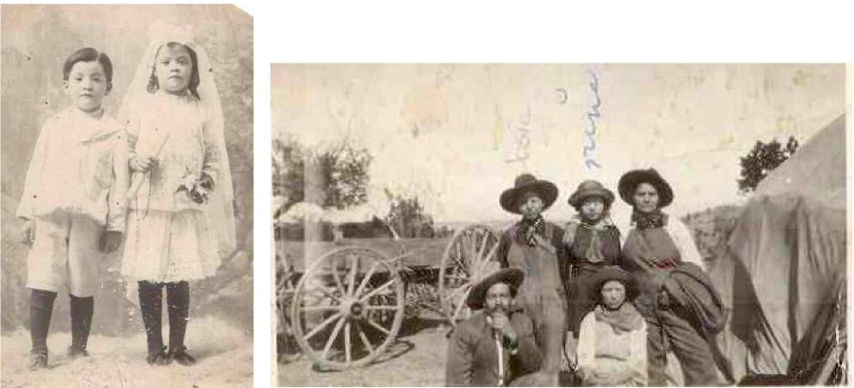

First image is of María Susana (Nina) Muñiz standing in first communion gown with possibly her brother Jess, unknown

date. Second image is Muñiz family in Arizona. Young male in back row identified as Jessie Muñiz and young female next to him identified and “Nina” (María Susana Muñiz). Photos provided by and identified by descendent of María Susana Muñiz.

Another migration out of Pajarito was not by a member of the servant families but rather a child of James Hubbell and Juliana. Although there were other migrations of this family out of Pajarito and the region, their son Francisco’s migration is of particular interest here because he continued to have household servants outside of Pajarito. Francisco Alarico Hubbell (born Oct. 12, 1862) moved to Santa Fe to attend San Miguel’s College in 1880. Shortly after, he married Trinidad Garcia and the couple are noted as living on Coal Avenue in Albuquerque in the 1900,1910 and 1920 censuses. The later censuses include two house servants in 1910 and one in 1920. Apparently, his large family moved to California where he died in 1929. In 1935 Roman Hubbell, a son of Francisco and Trinidad applied for membership to The New Mexico Society of Sons of the American Revolution for his early Hubbell ancestor’s service. The application, which was approved, presents genealogical information back to Comfort Hubbell, born in 1729 in Newtown, Connecticut, and his wife Susannah Baxter.16

11

1910 U.S. Census

By 1910, just two years before New Mexico’s statehood, only one household in Pajarito had a servant (not associated with the Hubbell family). The last of the direct Pajarito Gutiérrez /Hubbell family estate holders was that of Felipe J. and wife May Hubbell and their children Felipe (Jr.), Walter, Julianita, James. May Luisa. The dwellings adjacent to their home were that of Demetrio Muñiz and José Moraga whose 17 yr. old daughter Ruperta Moraga was listed as a laundress for a private family. Perhaps she worked for Felipe Hubbell. The rest of the neighboring properties belonged to old servant families discussed in this study such as Manuel Peña and Ruperta Rubi (daughter of Albino Rubi, son of Rafael Rubi); Blas Rubi, (son of Albino); Pablo or Pedro Muñiz (son and grandson of old Francisco Muñiz, former Gutiérrez and Hubbell servant); and José Manuel and son Patricio Sánchez. Manuel Sánchez was previously a laborer working for the Hubbells.

1920 U.S. Census

The household of May Hubbell, Pajarito postmaster, age 51 and widow of Felipe Hubbell was the first dwelling listed in the 1920 census of Pajarito. This positioning in the census enumeration indicates the enduring community power of this family. Listed are her six children Phillip J. (store bookkeeper), Julie (teacher), James, May, Harold and Louise. Also enumerated in this household was “farmhouse servant” Juan Rubí, white, 88 years old and noted as “too old to work.” This is most likely the Juan Rubi that was a boarder in the Jesus Muñiz and Juana Hubbell household in 1900. It is not known his connection to them or to the other Rubi persons discussed herein.

This census also included the dwelling of Frank Hubbell Jr. (age 26), farm manager, with wife Mable and daughter Geraldine. Their household included three servants: Vita Valdez, widower, White, house servant (age 63), who migrated from Mexico in 1909; Juan Peña, single, White, servant cook in

Hog ranch (age 26); and James Morrison, single, White (age 50), servant machinist in Hog ranch, born in Missouri, parents from South Carolina. The dwelling (in this case meaning property or estate) of Frank listed five separate non-Spanish surnamed households all apparently workers at the hog farm. The rest of the households in this census included those of farming families with surnames, Martinez, Padilla, and Gutiérrez. The later was that of Manuel (or Emanuel) Gutiérrez and wife Juanita Nuanes. They were married at San Felipe de Nerí, Albuquerque Church on Nov. 18, 1912. His parents were José Gutiérrez and Susana Sanchez, from Las Candelarias. Manuel’s 1918 draft card noted that he was a farmer, and his employer was F.A. Hubbell.

12

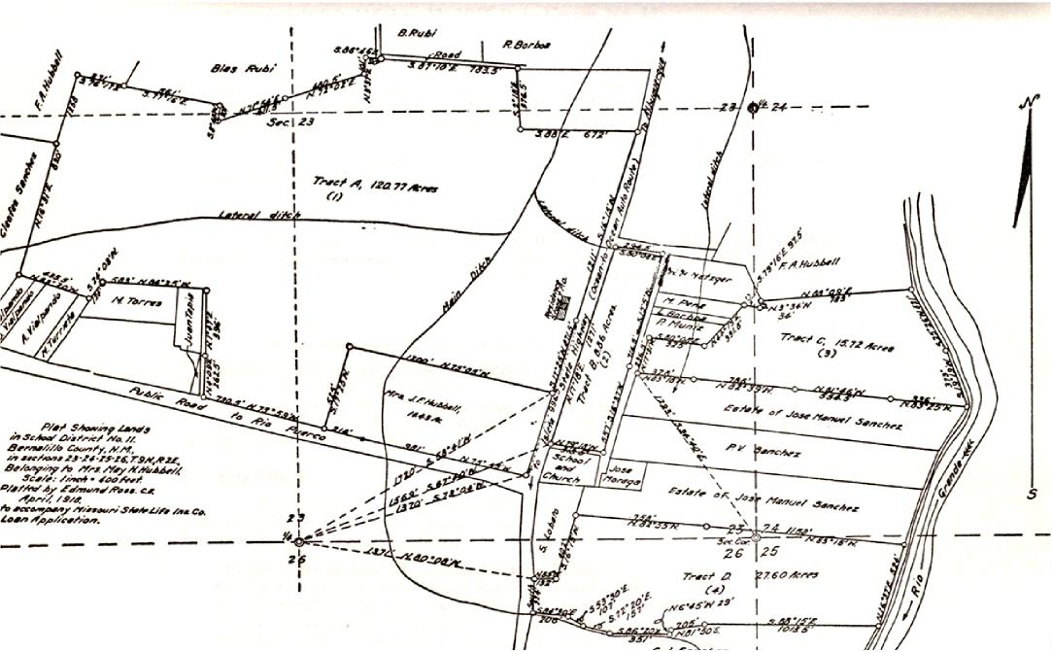

Plat map of lands of May Hubbell and adjacent properties, Bernalillo County, April 1918.

1930 U.S. Census

Listed first in this census was the Phillip (Felipe) Hubbell dwelling. Phillip was listed as the sheriff, single and living with his adult, single siblings May, Louise, and Harold. Listed after their house was another sibling - James Hubbell and wife Helen (All these siblings were children of Felipe Hubbell and May Helen Kelly and grandchildren of James Hubbell and Juliana Gutiérrez). Even though these two Hubbell houses listed no servants, these family members would have had firsthand memory of servants in their extended family households. It was this Felipe (Jr) in this census that would later in a

1972 interview recall that his grandmother’s family had many servants, and each child was given a “chichihua’ or wet nurse.17

13

The residences listed after the Hubbell households were those of the Ortiz and Castillo farmer families. This census saw a large influx of Anglo-American migrant residents in Pajarito. There was also one African American “Negro” family from Texas. E.W. Weaver was head of this household, a farmer, with wife Anne, “Neg” and Mabel, their 16-year-old daughter who was listed as a servant to a private family. Besides Mabel, there were four other young women (Spanish surnamed) living in their respective family households and listed as servants to private homes. The dwelling of F.M. Stubiling, from Nebraska, had an in-house servant named Agusta Gutiérrez, white, and 22 years of age. It is unknown her connection to the Gutiérrez/Hubbell family.

1940 U.S. Census

While it would be laborious to link all the extended families still in Pajarito and the surrounding area by 1940, the single remaining Hubbell household of May Hubbell (daughter of Felipe Hubbell and May Kelly) is perhaps one of the last remnants of the documented intersections between the Hubbell family and labor class families. In this 1940 census, the dwelling of May Hubbell, single, 34, owner of the house and her brother Harold, 32, single, also lists the family of Bernardo Bustamante, 32 and Augustina (Peña), 28, (divorcee of Nestor Metzgar) and 4 teenage children. Bernardo was noted as a laborer for the W.P.A. It can be surmised, given the pattern of servant families living in Gutiérrez /Hubbell homes and the fact that the census taker does not note that these two families are kin, this Bustamante family lived and served in this Hubbell house perhaps due to debt peonage.

Conclusion:

This history of intersectionality between elite landowners and Native American servants can be seen in almost every time period and locality in New Mexico. The inhumane and unwarranted systemic practice of enslaving others was not unique to this New Mexican family and community but rather it was widespread throughout the borderlands and indeed all of the Americas. Besides contributing to generations of despair for many and economic advantage for others, this practice also contributed to the emergence of regional Mestizo and Mulato Mexican/Hispanic/Latino cultures and communities.

This regional work’s focus on the U.S. censuses documents that the descendants of Juan Nepomuceno Gutiérrez and Barbara Chávez, the progenitors of the Gutiérrez and Hubbell family also continued this practice of Indian servitude forward into the Mexican and U.S. administrations. It also demonstrates that their house and farm servants, laborers and *peones* maintained intergenerational kinship relationships and association with the Gutiérrez / Hubbell family for over one hundred years.

Even though Tomás Gutiérrez summoned the *peones* to rebuild a fallen wall, it was the generations of these families highlighted in this study that built and populated the Pajarito community.

14

Although the legacy of these Pajarito social and familial relationships extends through exiled descendants throughout the U.S., it also remains in the memory of local Pajarito and Los Padillas old-timers, who on occasion reminisce about working for the “Jobles” (Hispanicized pronunciation of “Hubbells”) either picking their vegetables and fruits or taking care of their farm animals. Bringing this Pajarito story to a personal intersection note - my mother Rosalia Padilla is from the Padilla/Moraga families of Los Padillas and descends on a couple of lines from the early Baca Pajarito settlers. Her mother, Josefina Moraga, was also related to the servant Moraga Pajarito family mentioned in this essay. My mother and her siblings remember during the 1940’s-1950’s picking apples for the Hubbell family and having side jobs taking care of their horses.

Further attesting to the intergenerational continuity of family, place and memory and also to fluctuating and evolving social relations and agency - over twenty years ago, not as a paid worker but as a member of the Gutiérrez-Hubbell House Alliance board, I volunteered my labor at the property with several community and museum projects. This included organizing an outdoor film screening event, giving presentations on the history of Pajarito, and setting up the museum’s archives. I also rebuilt a section of a wall to a fallen adobe/rock horno – a modern functional installation for educational purposes. On another occasion, I reinstalled the ancient acequia system to the property and irrigated the fields and old apple orchard, which had not been done for several decades. Elias, my then teenage son, with a shovel in his hands helped control the flow of the gushing river water coming from the newly opened acequia gates to irrigate the thirsty grounds at the historic Gutiérrez-Hubbell estate.

1 Tomás Gutiérrez, Albuquerque to Ana Gutiérrez, Pajarito, Sept. 16, 1884, facsimile of document housed at the New Mexico State Records Center and Archives, David Brugge Papers, MSS 770, Box 12, Folder 41, Center for Southwest Research, UNM.

2 For a short narrative on Josefa Baca see: Sisneros, Samuel, “The Legacy of Josefa Baca,” *La Platica, Baca Family Historical Project Newsletter*, Winter, 2020 at <https://fliphtml5.com/xskub/hroz/basic> - Taken from Oct. 2012 publication in “La Bandera,” newsletter of the Hubbell House Alliance.

3 For the most extensive look into the Pajarito land grant see: Lujan, Elaine Patricia, “The Pajarito Land Grant: A Contextual Analysis of Its Confirmation by the U.S. Government,” Natural Resources Journal (Vol. 48, Fall, 2008). Download at: <https://digitalrepository.unm.edu/cgi/viewcontent.cgi?article=1188&context=nrj> . See also Martinez Christmas, Henrietta, “The Pajarito Land Grant and Its Heirs,” New Mexico Genealogist (Vol. 56, No. 4, Dec. 2017).

4 For an online presentation on Pajarito and to view the extractions of the 1750, 1790 censuses see: Sisneros, Samuel, “Pajarito Early Families,” *Prezi*, March 18, 2012, at <https://prezi.com/vhsriijmnlqo/pajarito-early-families/>

5 The popular definition of Coyote is usually 3/4 Indian. My research shows that a Coyote can also be a full-blooded Indian person brought up in an Indian servant family or was from a freed Genízaro family. In a previous study I did of Belen, New Mexico, I determined Coyote to be synonymous with Genízaro.

6 San Agustín de Isleta Church Marriage Registry, Aug. 30, 1841, AASF. The entry notes that José Antonio Montoya was the natural son of Candelaria Torrez and Juana Chávez was the daughter of José Chávez and Rafaela Baca, all from Los Padillas.

7 Racial labeling has been very fluid in New Mexico. At the time of the U.S. administration in New Mexico “White” was often used for Mexican/Hispanic persons to distinguish them from Indians.

15

8 San Agustín de Isleta Marriage Registry, Jan. 9, 1865, AASF. The marriage record of Juan Gutiérrez and Cornelia Pais does not note Juan’s parents but only states that Juan was raised in the house of Ana Gutiérrez, from Pajarito and that Cornelia was the daughter of José Pais y María Benavidez also from Pajarito.

9 Hubbell to Canby, 7 Apr. 1862, NMSRCA, Acc 1975-045, Box 1, Folder 1.

10 San Agustín de Isleta Baptismal Register, August 19, 1864, AASF.

11 Dolores was the daughter of Jesus “Arellano” and Ignacia García from Jarales, NM (1860 Census of Jarales). In the 1859 Belen marriage of Jesus and Ignacia he is listed as Jesus Arias from Chihuahua and Ignacia was from Jarales.

12 San Agustín de Isleta Baptismal Registry, month [illegible], 1882, AASF.

13 Even though the identity of Juana’s father is unknown, there is the possibility that James Hubbell, a Gutiérrez family male member (Juana sometimes used Gutierrez surname), or another servant male may have fathered her. In the San Agustín de Isleta baptismal register there is a record of the baptism on Sept. 2, 1866, of Juana María Gutiérrez, daughter of Juan Gutiérrez and María Chávez. The godparents are Juan Castillo y Cruz Muñíz. The 1866 baptism coincides with the birth year given of the Juana Hubbell in the 1885 census. The Sept. 2 date of the “Juana María Gutiérrez” baptism coincides with the 1910 census note of “Aug. 1866” birth of the Juana married to Jesus Muñiz since usually a child is baptized within a few days to a few weeks after birth. The Juana María of the baptismal record is listed as the “legitimate” daughter of Juan Gutiérrez and María Chávez. This could be an attempt to legitimize the servant child by inserting the names of Juan Gutierrez and María Chavez as “legitimate” parents. These names could only be referring to Juan Nepomuceno Gutiérrez and “Barbara” Chávez, the surrogate parents or “masters.” Barbara was 60 years old at this time and would not have been able to give birth to a child. Beside Juan N. Gutiérrez there were two other Juan Gutiérrez named persons during this time living in Pajarito. One was Juan Gutiérrez, married to Esmael Chávez. This couple gave birth to a daughter on Jan 7th of the same year. The other was the Juan Gutiérrez married to Cornelia Lente. Both couples are discussed early in this essay as possibly being servants of Juan Nepomuceno Gutiérrez.

14 See John M. Nieto-Phillips. *The Language of Blood: The Making of Spanish-American Identity in New Mexico, 1880s– 1930s*. Albuquerque: University of New Mexico Press. 2004

15 I contacted a descendent of Jesus Muñíz and Juana Hubbell (Gutierrez) whose family has resided in California for a couple of generations. This person provided me the images and family history. María Susana (Nina) Muñíz in the image with her first holy communion gown is Gina’s great grandmother. María Susana was the daughter of Jesus Muñíz and Juana Hubbell. She was born 26 November 1902 in Pajarito an baptized at San Felipe de Nerí church. She went by Susie and married Nicanor Gonzales Cordova. On November 8, 1993 she passed away in Redondo Beach, CA, where she is buried.

16 U.S. Sons of the American Revolution Membership Applications, 1889-1970, [Ancestry.com:](http://Ancestry.com:) <https://www.ancestry.com/imageviewer/collections/2204/images/32596_242486-> 00211?usePUB=true&usePUBJs=true&pId=1137964

17 McNitt, interview with Phillip Hubbell, 1972; NMSRCA.